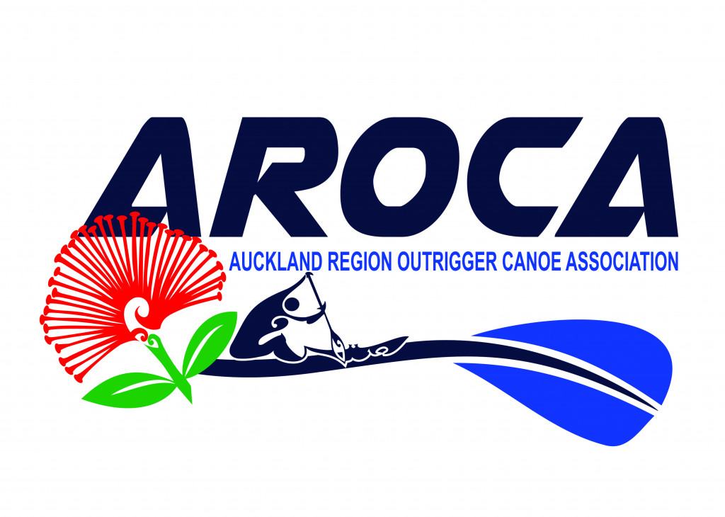
WAKA AMA NEW ZEALAND
INDIVIDUAL EVENT WAIVER and AUTHORITY FORM
AROCA - W1 Regionals – 7th & 8th November 2026
I declare that:
- My accepted entry will not be transferred to another entrant.
- In the event of any “act of God” conditions causing a cancellation of the event, my total entry fee is not transferable or refundable.
- I acknowledge that there are risks involved with Waka Ama and fully realise the dangers of participating in an event such as this and fully assume the risks associated with such participation and my wellbeing during the event.
- I understand and agree that situations may arise during the event, which may be beyond the immediate control of officials or organisers, and I must continually participate in a manner that does not endanger either myself or others.
- Neither the organisers, the sponsors nor other parties associated with the event shall have any responsibility, financial or otherwise, for any risk incident that might arise, whether or not by negligence, from any direct or indirect loss, injury or death that might be sustained by me or any other party directly or indirectly associated with me, from my intended or actual participation in the event or its related activities.
- I authorise my name, voice, picture and information on this entry form to be used without payment to me in any broadcast, telecast, promotion, advertising, or any other way pursuant to the Privacy Act 2020.
- I agree to comply with the rules, regulations and event instructions of the event.
- I consent to receiving medical treatment which may be advisable in the event of illness or injuries suffered during the event.
- I can confirm that I can swim 50 Metre/ OR if I cannot swim 50 Metres I will wear a PFD during the race.
Medical declaration:
Do you have any medical conditions event hosts should be aware of?
Yes  No 
If yes, provide relevant information _____________________________________________________ _________________________________________________________________________________ __________________________________________________________________________________________________________________________________________________________________
Emergency contact:
Name ___________________________________________________________________________ Phone ___________________________________________________________________________

Declaration:
I hereby declare my understanding and acceptance of the event waiver and statements within.
Full Name of competitor _____________________________________________________________
Signed _____________________________________________ Date _________________________
Date of birth __________________
If competitor is under 18 the waiver must be signed by a Parent or guardian:
Full name of Parent/guardian _________________________________________________________
Signed _____________________________________________ Date _________________________
Important Note to event organisers: The Waiver must be explained to all individuals and consideration must be given for those participants who may not be able to read or understand English.

